Assignment 7

# Exercise 1

# Exercise 2

## Interval = 10

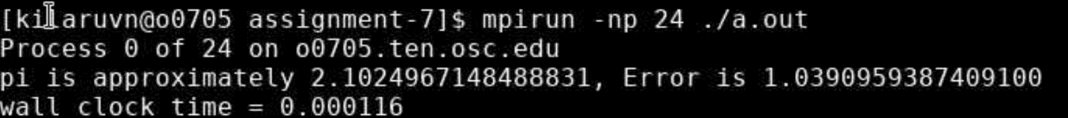

## Interval = 10^2

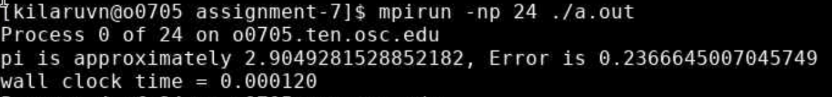

## Interval = 10^3

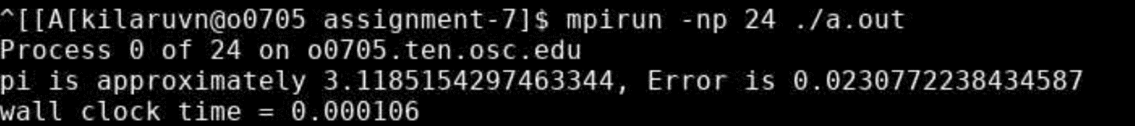

## Interval = 10^4

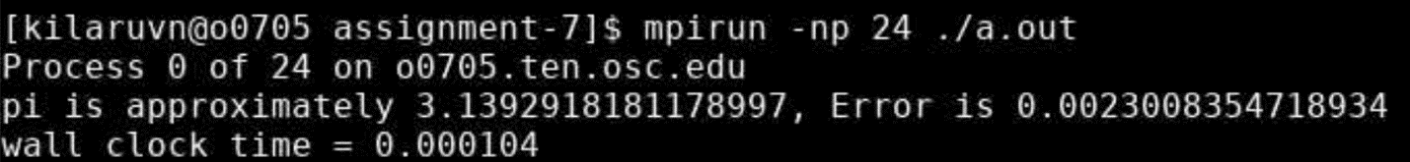

## Interval = 10^5

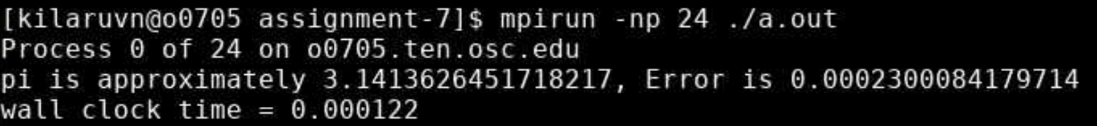

## Interval = 10^6

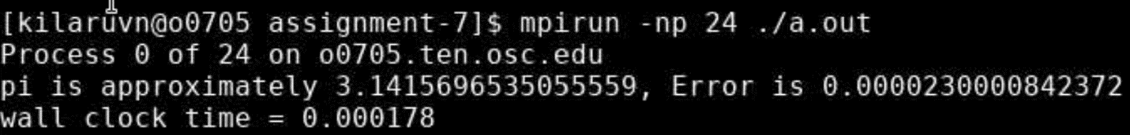

## Interval = 10^7

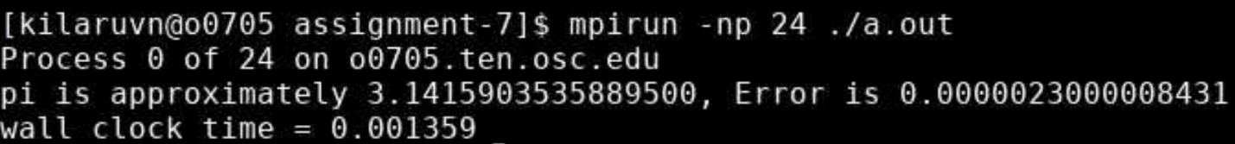

## Interval = 10^8

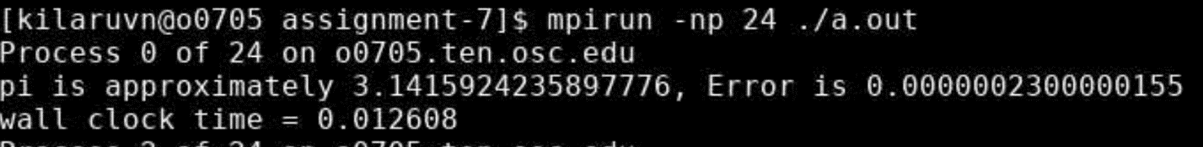

## Interval = 10^9

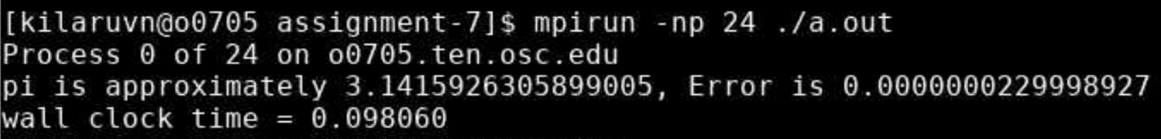

## Interval = 10^10

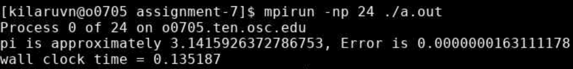

## Table

|  |  |  |  |
| --- | --- | --- | --- |
| Interval Size | PI Value | Error | Accuracy |
| 10^1 | 2.102496715 | 1.039095939 | 50.57799941 |
| 10^2 | 2.904928153 | 0.236664501 | 91.85299986 |
| 10^3 | 3.11851543 | 0.023077224 | 99.25999328 |
| 10^4 | 3.139291818 | 0.002300835 | 99.92670846 |
| 10^5 | 3.141362645 | 0.000230008 | 99.99267807 |
| 10^6 | 3.141569654 | 2.30001E-05 | 99.99926788 |
| 10^7 | 3.141590354 | 2.3E-06 | 99.99992679 |
| 10^8 | 3.141592424 | 2.3E-07 | 99.99999268 |
| 10^9 | 3.141592631 | 2.29999E-08 | 99.99999927 |
| 10^10 | 3.141592637 | 1.63111E-08 | 99.99999948 |

## Plot